Training Day – 27

October 25, Friday*

* *Topic:* Descriptive Analysis with Pandas
* Summarized data using .describe(), .mean(), and .sum().
* Example: Analyzed a dataset's central tendencies and spread.

Today I made my own data set and convert it into DataFrame and apply some functions of pandas library. Like - .info(), .set_index(), .reset_index(), adding an column name

'Roll no.' ,.drop().

•Also done 'Indexing' and 'Slicing' on large dataset for reading the data according to given rows and column detail, using '.iloc' function.

•Also practice for feeling NAN values by identifying outliers, with the help of mean, median,mode.

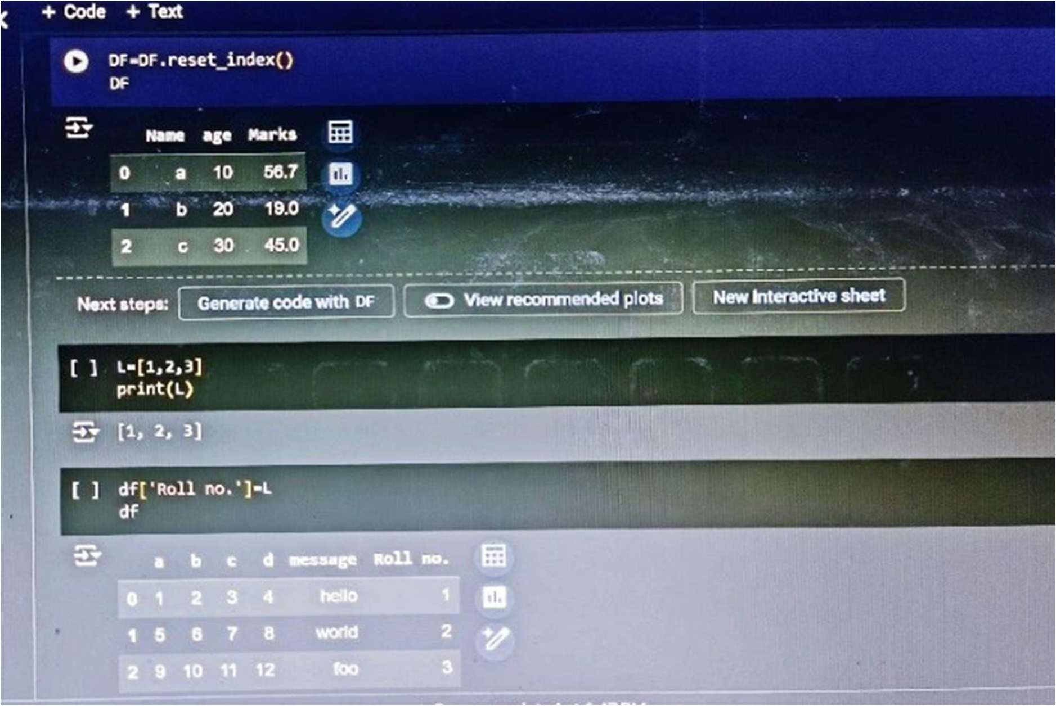

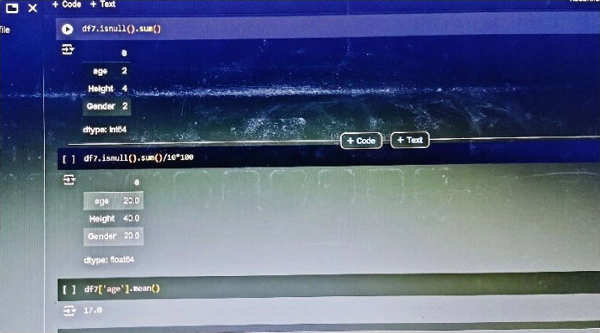

df = pd.DataFrame({"Values": [10, 20, 30, 40, 50]}) print(df.describe())